Orthographic drawing
Name: Class: Date:

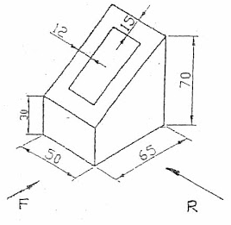
Draw the following shapes on the squared grid below using the dimensions and third angle projection.

