Orthographic Drawing

Name: Class: Date:

In the box below draw an orthographic drawing of a cube

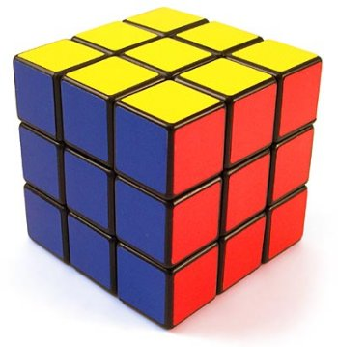

In the box below draw an orthographic drawing of ‘L’ shape using third angle projection.

