Orographic Projection

Name: Class Date:
Choose the figure that shows the orthographic drawing of the object.
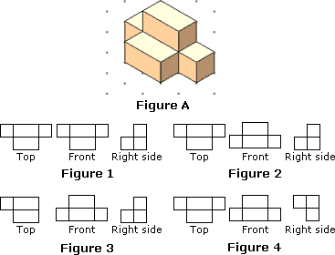

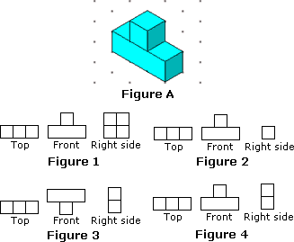
Identify the figure that shows the orthographic drawing of the object below shown.

Identify the figure that shows the top-front-right views of the figure shown.
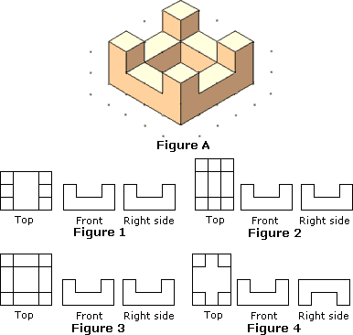

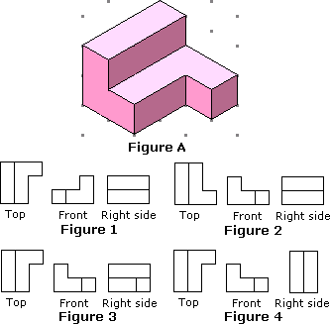
Which figure shows the top-front-right views of the figure shown?
 | a. |  | Figure 4

Identify the figure that shows the top-front-right views of the figure shown.
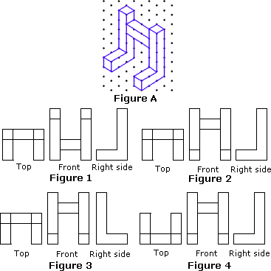

Choose the figure that shows the top-front-right views of the figure shown.
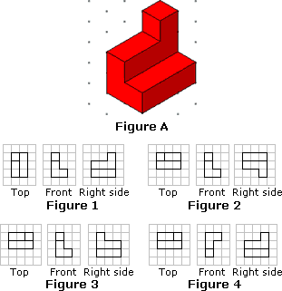

(http://worksheets.tutorvista.com/3d-shapes-worksheets.html?page=1)

