Choose the figure that shows the isometric view of the orthographic drawing shown.
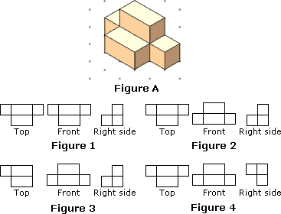

Identify the figure that shows the isometric view of the orthographic drawing shown.
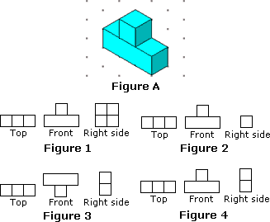
Identify the figure that shows the top-front-right views of the figure shown.
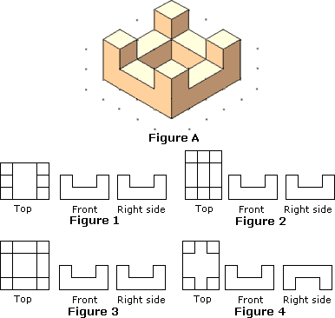

Which figure shows the top-front-right views of the figure shown?
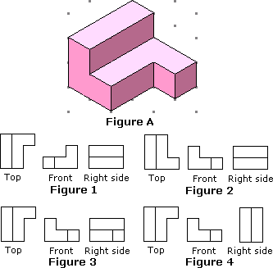
 | a. |  | Figure 4

Identify the figure that shows the top-front-right views of the figure shown.
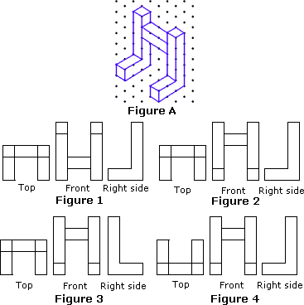

Choose the figure that shows the top-front-right views of the figure shown.
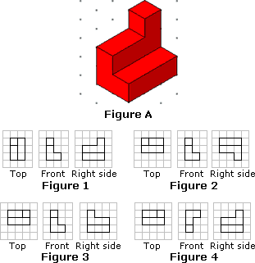

(http://worksheets.tutorvista.com/3d-shapes-worksheets.html?page=1)

